SHOWCASE TITLE: CROSS-BORDER E-CMR

SHOWCASE PARTNERS (DIGINNO project partners and external stakeholders):

Lithuania: Lithuanian national Information and Communication Technology association INFOBALT, Lithuanian Road Carriers association LINAVA, Lithuanian Ministry of Economy and Innovation, Lithuanian State Tax Authority, Lithuanian Road transport administration, Lithuanian Customs Service
Latvia: Latvian Information and Communications Technology Association (LIKTA), Ministry of Transport of Latvia, Road Transport Administration of Latvia
Poland: Polish Chamber of Commerce for Electronics and Telecommunications, Polish Road Transport Institute, International Road Transport Carriers in Poland,, General Inspectorate of Road Transport Ministry of Digitalisation, Ministry of Entrepreneurship and Technology; Trans.eu Group.
Estonia: Ministry of Economic Affairs and Communications, Single Window Initiative Estonia, Prolog Estonian Supply Chain Association, ERAA, Intepia, Tieto Estonia AS

PROBLEM IDENTIFIED IN THE SHOWCASE

Currently, the exchange of the electronic logistic documents , i.e. eCMR, is not a reality, the relevant authorities do not get access to eCMR data in electronic way either. There are service providers which provides eCMR service (i.e. Pionira, Mobicarnet, Transfollow, etc.) and there are governments capable and interested to read the data that they are entitled to check. However, the problem is that the Governmental institutions of partner countries can not accept the electronic eCMR, event if the legal ground for it exists participating countries. However what is missing – the secure and trustful way to exchange the eCMR data between the Government and Businesses, and to provide such connectivity of the services and information internationally - between different partner countries’ governments and eCMR services.

SCOPE OF SHOW CASE
The purpose of the FS was to review the current situation and make recommendations on the digitalization of the cross-border electronic consignment notes (CMR), evaluating the relevant technical, legal, institutional, economic and other aspects mainly in the project countries. The analysis reviewed the current state of affairs, that create the environment for the implementation of the electronic CMR Consignment Note in electronic format based on the "Additional Protocol to the Convention on the contract for the international carriage of goods by road (CMR) concerning the electronic Consignment note".
The DIGINNO project and the analysis is supporting the creation of electronic CMR document/data exchange pilot service between Baltic Sea region's countries. The analysis supports the further outlook that eCMR would be legally accepted and used by each participating country in the Baltic Sea Region. So that each participating country would legally accept its data exchange, signing and storage policies. It is expected that private logistics companies (carriers, receivers, brokers, etc.) and governmental organizations would have tools to access e-CMR documents/data and accept them as paper analogues.

OUTCOME OF THE SHOW CASE

The Cross-border e-CMR architectural solution was developed by partners (see the scheme bellow) and related technical, legal, design recommendations needed for the implementation of solution proposed.

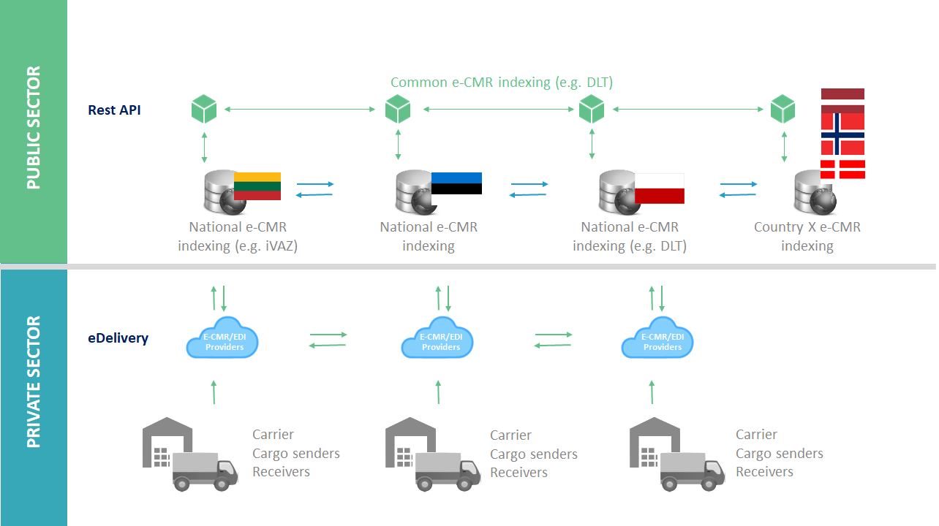

Solution Design recommendations
The design of e-CMR must to respond to the best practices of European Union by using the CEF e-delivery infrastructure. PEPPOL e-delivery support is already implemented in Denmark. The example of realization of best practices could be e-invoicing implementation on European Union level.
The design of e-CMR must apply principles "digital by default" and "once only". Industry and many governments must increase efficiency by going digital. Efficiency could come from the incorporation of various e-Government systems (national e-CMR indexing and storage system, excise information system, statistical declaration system, e-custom system, e-invoicing system, e-Court system, etc.) into a national digital Single Window. By delivering such necessity, the integration is required between e-Government systems. Validation of juridical data and the type of economic activity for the party listed into e-CMR could be provided retrieving data from the e-Register system, which has recent information on European Union level synchronized once a calendar day.
The declaration of transit countries could be included in the e-CMR system as data provided by the carrier. Such could guarantee shorter carrier disruption during the authorities' inspection case, when the controlling authority is accessing cross-border e-CMR system. Moreover, it would also strengthen the control of authorities, which would be able to match declared transit flow with actual transit flow at the point of control installed in transit country. For that, electronic data infrastructure must be developed.
For prototyping it is recommended to develop solution compliant with the Architectural Decision agreed upon in the DIGINNO project (and is presented under Fig. 7). The architectural solution agreed to implement through the eDelivery principle, a consensus standard between the parties and a messaging format. The central system in the country is recommended for maintenance of central index.
It is recommended to have accreditation for Technology service providers as eligible ones, which are accredited to supply electronic consignment notes delivery. To implement accreditation process, National Government must appoint the national authority, which is responsible for accreditation. Based on Benelux region example provided, the Ministry of Mobility and Public Works is appointed for the accreditation under Benelux countries. After accreditation, Technology service providers in Benelux countries are excluded from the list of accredited suppliers, if their technology no longer meets the conditions of the Benelux Decision and/or the protocol: the electronic consignment note no longer contains the same information as the paper consignment note; the process used for the establishment of the note no longer guarantees the integrity of the information contained in it (full and unaltered indications); and the information contained in the note is no longer be supplemented or modified.
During e-CMR implementation pilots are optionally selected and delivered by industry. In the transitional period it is recommended to have both paper-based and electronic-based Consignment notes. The end of the transition period could be specified by authorities giving time for the industry to prepare for paperless Consignment note and their usage in daily operations early in advance.
The implementation of complex cross-border e-CMR solution could be separated into four phases: (1) prototype implementation, (2) the installation of simplified fully working solution, (3) the establishment of advanced solution and (4) provision of solution covering Single Window concept. The realization of first two phases could last around 2-3 years. The achievement of advanced solution could take 5-6 years, in accordance to Estonian project partners’ estimation. The provision of solution supporting Single Window concept depends on priorities of National governments.

Technical recommendations
Each country has their own technical solutions and state systems already invested, so, in order to ensure technical interoperability for cross-border e-CMR solution it is recommended to use such technical standards:
1. Compatibility and reliance on international e-CMR standard, which is developed by United Nations Economic Commission for Europe (abbreviated UNECE) and the first version is launched on 2018.02.16.
2. E-identification and authentication standards in accordance with eIDAS, supported by ENISA.
3. Digital/electronic signature and/or seal (e-Seal) standard, which is provided by same eIDAS framework;
4. Digital time-stamp in accordance with eIDAS;
5. E-Security standards meeting the eGovernance and secure data exchange levels;
6. EU-wide accepted file format and delivery standards, incl Connecting Europe Facility (CEF) eDelivery building block);
7. Indexing format and standard which are applied in compliance with eGovernance principles, implemented possibly also partially with Distributed Ledger Technologies solutions;
8. Electronic Archiving standards; with specific requirements or technical/organizational aspects. Standard is involved to reduce risks such as changing regulatory requirements and the disclosure of confidential records and can furthermore enhance the security layer of information by easily enforcing security policies and logging. Companies using the e-archive in combination with a built-in workflow engine can react to new processes, and requirements with more agility. It is recommended to align storage policies between countries, while minimized requirements for electronic archiving in comparison to paper e-CMR to have higher acceptance of e-CMR solution by business, shouldn’t be forgotten.
Adoption of common standards and interoperability is highly appreciated rather than specific software implementation in the context of e-CMR. On the other hand, all solutions and standards chosen must be compatible with eGovernance solutions in the applying countries to allow the business-to-government data exchange.
The state control authorities must take care to become a gateway to obtain the necessary data from the national e-CMR providers to their systems, in case many e-CMR solutions are present in the country. To ensure technical interoperability recommended to dedicate the function to single institution responsible for the technical compliance. All technical standards such as e-identification and authentication (eID, eIDAS), digital/electronic signature and/or seals, e-Security and others are successfully handled by Norwegian, Danish and Estonian eGovernment and could be benchmarked.
For reaching technical interoperability, the data structure of e-CMR must be enforced by regulation. The regulation concerning technical interoperability could be updated periodically not as often as once in two years period.
Connection with other countries could be implemented by adopting CEF e-Delivery elements. National e-CMR indexing system could in long term be built up using DLT (Distributed Ledger Technologies), connection with international or global indexing systems must be foreseen for each national e-CMR indexing system.
On technical side, e-CMR fall back procedure must be stated in regulation for the cases when national e-CMR indexing and storage system is crashed. After the system begins to operate, recovery data must be restored.

Legal recommendations
To make e-CMR working internationally, a mutual agreement on sub statutory legal issues (e-CMR digitalization) is needed to initiate the most immediate effects thereof within the countries involved. The use of the electronic consignment note is made possible by article 1, paragraph 5 of the CMR Convention. The e-CMR-protocol serves as a guide for the CMR Convention. Thus, the agreement would apply to transport within the boundaries of the involved countries.
The Pilot project of Benelux countries (yet not finished) has already revealed that such kind of an agreement should acknowledge e-CMR is valid as far as it: (i) complies with art. 1-6 of the e-CMR protocol; (ii) is produced by a party with the technology of an admitted provider; (iii) is used by a reported user. The e-CMR note should contain a unique number, a digital signature and all other information as paper CMR. Also, it should be accessible and downloadable for all contracting parties.
To move forward with e-CMR implementation, it is recommended for the national governments of to ratify the Additional protocol to the Convention on the contract for international carriage of goods by road (CMR) concerning the electronic Consignment note.
Also, naturally, many other legal aspects should be regulated. E-CMR signing procedure is of the greatest importance, especially Qualified Electronic Signatures (QES) implementation. Therefore, requirements for digital signature should be covered too. Concerning the protection of data, the public authorities shall be only allowed to use the received data in the area of their competence, not communicating these data to other not related public authorities. Also, the national and European regulation concerning privacy shall be respected. As to the whole IT system regulation, it is a repository storing of all data related to the specific e-CMR that should be the object of the relevant law. The data should be only accessible to those parties that have a specific role as to the specific e-CMR. It should offer apps to access the data, to sign for transfer of the goods. Subsequently, the system should offer a portal that allowed parties to view their freight documents and to retrieve them for printing or forwarding purposes. Firms and Authorities should follow functional Architectural solution, allowing to have efficiency increase and reduction of redundant workflows.
For cross-border e-CMR establishment it is recommended to implement sub-statutory national legal acts explaining:
- The indexing of cross-border e-CMR,
- The electronic form of Consignment Note by stating that is legally applicable,
- The rules of submission of cross-border e-CMR,
- The information exchange between DIGINNO project partner countries.
To ease the burden on business, it is recommended to foresee the option in legislation that national waybills could be reported by using e-CMR data structure and technical standards and by setting the time for such option appearance.
The implementation of cross-border e-CMR solution, which meets technical interoperability, could be funded from European Union structural funds.

https://guichet.public.lu/en/entreprises/marche-international/transport/routier/agrement-fournisseur-lettre-voiture-electrique.html
Such as ISO27000 ISMS and/or ISAE3000 SOC
https://treaties.un.org/pages/ViewDetails.aspx?src=TREATY&mtdsg_no=XI-B-11-b&chapter=11&clang=_en

